**PROJECT REPORT ON**

**“ANALYSIS ON WORLD COVID-19 DATA FROM MAY-JUNE OF 2021”**

**FOR**

**“IN HOUSE PROJECT”**

Submitted By

MR. USAID MULLA

MR. EMAAZ SHAIKH

Master of Computer Application Savitribai Phule Pune University

ALLANA INSTITUTE OF MANAGEMENT SCIENCES AZAM CAMPUS, CAMP, PUNE 411001

(2018-2021)

**PROJECT REPORT**

**On**

**“Analysis On World Covid-19 Data from May-June month of 2021”**

**For**

**“In House Project”**

**By**

**Mr. Usaid Mulla**

**Mr. Emaaz Shaikh**

**MCA-III**

**Track-III Roll No-31**

**Roll No-41**

**Academic Year 2020-2021**

**Guide-Prof. Haridas S. Acharya & Prof. Jawed Khan**

**M.C.E. Society’s**

**Allana Institute of Management Sciences, Pune 2018-2021**



**Undertaking**

I / We hereby declare that, the project entitled **“Analysis on World Covid-19 Data” for “Inhouse Project”**, have completed and written by me / us. Current project has not previously formed the basis for the award of any Degree or Diploma or other similar title of this or any other University or examining body.

Place: Pune

Date: 23 August 2021

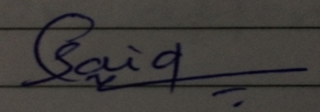

**Signature Signature**

Usaid Mulla Emaaz Shaikh

**DECLARATION**

I/We hereby declare that the project work entitled “Analysis on World Covid-19 Data” submitted to the Savitribai Phule Pune University, Pune, is a record of an original work done by us and this project work is submitted in the partial fulfillment of the requirements for the award of the degree of Master of Computer Application. The project work in this report has not been submitted to any other University or Institute for the award of any degree or diploma.

As authors of this Group Project report, entitled Analysis on World Covid-19 Data our signatures on the document signify our joint responsibility in this project.

|  |  |  |  |
| --- | --- | --- | --- |
| **Sr. No.** | **Seat No.** | **Name of Student** | **Functionality/ Module** |
| 1 | 11295 | Usaid Mulla | I have done my work on analysis, creating dashboards, reports & documentation part. |
| 2 | 11298 | Emaaz Shaikh | Work done on ETL/preprocessing, analysis & documentation part. |

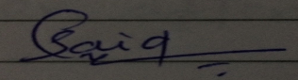

Sign. ____________________ Sign. ________________________

Usaid Mulla Emaaz Shaikh

This Group Project Report is authored by Allana Institute of Management Sciences’ students and has been reviewed and approved by:

Sign. ____________________ Sign. ________________________

Prof. Jawed Khan Dr. H. S. Acharya

**ACKNOWLEDGEMENT**

I / We take pleasure in presenting my / our project work. I / We am / are thankful to my / our project guide **Dr. H. S Acharya & Prof. Jawed Khan** of AIMS**,** who keeps monitoring my / our project continuously to complete it in time as per the expectations of the course.

***“Ability is of little account without opportunity”***, I / we wish to thank our Director **Dr. (Prof) Roshan Kazi**, who gave me / us a very bright learning opportunity, during my / our course to prove my / our ability and skills.

Last but not least I / We would like to express my / our heartfelt gratitude towards staff members of AIMS, my / our colleagues and friends for their moral and technical support throughout the duration of the project.

|  |  |  |
| --- | --- | --- |
| My / Our sincere thanks to all |  |  |
| 1. **Usaid Mulla** 2. **Emaaz Shaikh** |  |  |

|  |
| --- |
| **INDEX** |

|  |  |  |
| --- | --- | --- |
| **Sr. No.** | **Title** | **Page No.** |
| **1.** | **Introduction** | 05 |
| **1.1** | **Objectives of Project** | 09 |
| **1.2** | **Scope of the Study / Project** | 11 |
| **1.3** | **Technology to be used** | 12 |
| **2.** | **Data Collection** | 12 |
| **2.1** | **Description & size of the Data** | 15 |
| **2.2** | **List of Variables** | 15 |
| **3.** | **Business Models** | 16 |
| **4.** | **Pre-Processing** | 17 |
| **5.** | **Data Analysis** | 19 |
| **5.1** | **Key Performances Indices** | 20 |
| **5.2** | **Dashboard** | 21 |
| **5.3** | **Interactive Reports** | 26 |
| **6.** | **Results and discussions** | 28 |
| **7.** | **Conclusion & future work** | 31 |
| **8.** | **Glossary** | --- |
| **9.** | **Bibliography** | 32 |

**Chapter I**

**INTRODUCTION**

1. **Introduction to Covid-19:**

The World Health Organization (WHO) has declared the coronavirus disease 2019 (COVID-19) a pandemic. A global coordinated effort is needed to stop the further spread of the virus. A pandemic is defined as “occurring over a wide geographic area and affecting an exceptionally high proportion of the population.”  The last pandemic reported in the world was the H1N1 flu pandemic in 2009.

On 31 December 2019, a cluster of cases of pneumonia of unknown cause, in the city of Wuhan, Hubei province in China, was reported to the World Health Organization. In January 2020, a previously unknown new virus was identified, subsequently named the 2019 novel coronavirus, and samples obtained from cases and analysis of the virus’ genetics indicated that this was the cause of the outbreak. This novel coronavirus was named Coronavirus Disease 2019 (COVID-19) by WHO in February 2020.

**Live data can be accessed here: -**

COVID-19 Dashboard by the Center for Systems Science and Engineering (CSSE) at Johns Hopkins University (JHU)

<https://www.arcgis.com/apps/dashboards/bda7594740fd40299423467b48e9ecf6>

**What is Coronavirus?**

Coronaviruses are a family of viruses that cause illness such as respiratory diseases or gastrointestinal diseases. Respiratory diseases can range from the common cold to more severe diseases.

Symptoms may include:

* Respiratory symptoms
* Fever
* Cough
* Shortness of breath
* Breathing difficulties
* Fatigue
* Sore throat

**High-Risk Populations:**

The virus that causes COVID-19 infects people of all ages. However, evidence to date suggests that three groups of people are at a higher risk of getting severe COVID-19 disease

* Older people (people over 70 years of age)
* People with serious chronic illnesses such as:
  + Diabetes
  + Cardiovascular disease
  + Chronic respiratory disease
  + Cancer
  + Hypertension
  + Chronic liver disease

**Transmission of COVID-19:**

Evidence is still emerging, but current information is indicating that human-to-human transmission is occurring. The routes of transmission of COVID-19 remains unclear at present, but evidence from other coronaviruses and respiratory diseases indicates that the disease may spread through large respiratory droplets and direct or indirect contact with infected secretions.

Transmission can occur more easily in the “Three C’s” (the risk of COVID-19 spreading is higher in places where these “3Cs” overlap):

1. Crowded places with many people nearby;
2. Close-contact settings, especially where people have conversations very near each other;
3. Confined and enclosed spaces with poor ventilation.
   1. **Objectives of project**

* Analytics on Covid-19 data help us predict the how pandemic is going on so far and what are the worse impact on world.
* In analysis we used secondary data which is from publicly shared data.
* Data is been ETL from “**worldometer.com**” with the help of python script in “Jupyter Notebook” run by line-by-line codes.
* The source code is been used from “**Towards-Data Science**” called “**Scraping COVID-19 data using python**” By “**Aboze Brain John Jnr**”.
* In two different data set there are two hundred and above countries, we’re analysis on particular six countries and study on that who is more effected country in May-June months.
* In this analysis there are two different dataset one is 15-May-2021 and another is after 15 days which is 01-June-2021.
* The major aspect of study on two dataset is before & after fifteen days is any changes in covid-19 statistics or not.
* The study on six major affected countries in covid-19 analysis are “**USA, India, Brazil, France, Russia, UK**” which we’re opt.
* To study and identify in six countries the attributes are which we have analysis on “**Active Cases, New Cases, New Deaths, New Recovered, Serious & Critical Cases, Total Cases, Total Deaths, Total Recovered, & Total Test**, done so far.
* To Study and identify minimize social and economic impact through multisectoral partnerships.
* To communicate critical risk and event information to all communities and counter misinformation.
* Identify, isolate and care for patients early, including providing optimized care for infected patients.
* Identify and reduce transmission from the animal source.
* This data can be achieved through a combination of public health measures, such as rapid identification, diagnosis and management of the cases, identification and follow up of the contacts, infection prevention and control in health care settings, implementation of health measures for travellers, awareness-raising in the population and risk communication.
* To study the increase test kit and vaccination drive among all age groups.
* To study the status of all over the world covid-19 circumstances.
* To identify the changes and mitigate after comparison of two dataset of 15 days of time period.
  1. **Scope of the study / Project:**

The scope of the study is limited to the analysis of during the peak time of covid-19 all over the world in May-June of 2021, the data is collection in terms of two time period one is 01-May-2021 & after two weeks on 01-June-2021. Further the study focused on assessing in case of test, positivity, fatality, tests and health & medical infrastructure of public safety.

The aim of the study is to give insights of aggregation of six major effected countries in the world which are USA, Brazil, India, UK, Russia, France, etc. in terms of positivity rate, active cases, total death, mortality/fatality, total recovered/new recovered, new cases, serious/critical cases, total cases, total test rate, etc. also identify on 15-May-2021 suppose USA leading on top position in cases of positivity rate or mortality but after 15 days 01-June-2021 the cases of positivity rate of position either not change but also the volume of positivity and death toll rate of stats are different, because perhaps people become aware and taking precautions and following the government norms properly.

The study includes the comparison of two data sets of all the countries in the world identify the New Cases vs New Recovery rate by May Month as well as same in June Month so in may month the country India is top most leading country in both new cases & new recoveries rate but also in the study of June data identify the Bolivia country is top most leading in new cases & new recovery rate, so analyze those big changes in countries position are being shifted to another position.

* 1. **Technology to be used:**

-Anaconda Jupyter Notebook (Python Script)

-Excel

-MSPBI (Microsoft Power BI)

**S/W and H/W Specification**

Hardware Specification

|  |  |
| --- | --- |
| Processor | Intel corei5,4th Gen |
| Memory (RAM) | 1GB Minimum |
| Hard Disk Space | 512 GB |
| Monitor | Higher resolution |

1. **Data Collection:**

* Data has been collected and live scraped from: <https://www.worldometers.info/coronavirus> website with the help of python scripting, also the data we used which is secondary data from publicly shared data.
* **About Worldometer.com:**

**Worldometer** formerly website that provides counters and real-time statistics for diverse topics. It is owned and operated by a data company Dadax which generates revenue through online advertising. It is part of the Real Time Statistics Project, and is allegedly managed by "an international team of developers, researchers, and volunteers".It is available in 31 languages and covers subjects such as its government, world population, Economics, society, media, environment, food and water, energy, and health.

* **Source code link of python script:**

The below link is towards data science from where we get python code for web scraping of “analysis on world covid-19 data”, and the python script run in jupyter notebook of anaconda IDE (Integrated Development Environment).

* [**https://towardsdatascience.com/scraping-covid19-data-using-python-80120eb5eb66**](https://towardsdatascience.com/scraping-covid19-data-using-python-80120eb5eb66)**.**

**Web scraping** is a term used to describe the use of a program or algorithm to extract and process large amounts of data from the web. Whether you are a data scientist, engineer, or anybody who analyzes large amounts of datasets, the ability to scrape data from the web is a useful skill to have.

Worldometers has a credible source of COVID19 data around the world. In this article, we will learn how to scrape COVID19 data depicted below from a web page to a Desk data frame from the site using python.

**Python code:**

* import requests
  + page=requests.get("https://www.worldometers.info/coronavirus")
* page.status_code
* from bs4 import BeautifulSoup
* #Instatiating the BeautifulSoup Class
  + soup = BeautifulSoup(page.content, 'lxml')
  + #Where soup is a variable containing the HTML of the webpage
* #Lets formatt it nicely, using the prettify method as contrasts as cell 3
* print(soup.prettify())
* # Search for the table and extracting it
* table = soup.find('table', attrs={'id': 'main_table_countries_today'})
* table
* rows = table.find_all("tr", attrs={"style": ""})
* data = []
  + for i,item in enumerate(rows):
  + if i == 0
  + data.append(item.text.strip().split("\n")[:17])
  + else:
  + data.append(item.text.strip().split("\n")[:16])
* data
* import pandas as pd
  + import dask.dataframe as dd
  + dt = pd.DataFrame(data)
  + dt = pd.DataFrame(data[1:], columns=data[0][:16]) #Formatting the header
  + df = dd.from_pandas(dt,npartitions=1)
* df.head(10)

**Final Output:**

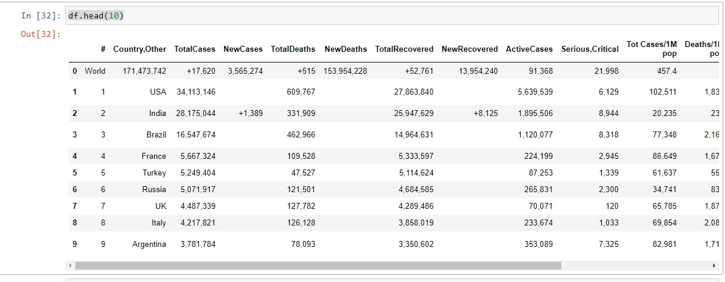

* 1. **Description & Size of the Data**

|  |  |  |
| --- | --- | --- |
| **File Name** | **Size Of data** | **Description** |
| 15-May-2021 | 325 KB | Attributes: 15  Records: 210 |
| 01-June-2021 | 250 KB | Attributes: 15  Records: 211 |

* 1. **List of Variables:**

|  |  |
| --- | --- |
| **Name Of the attributes** | **Data types** |
| Country | String |
| Total Cases | Integer |
| New Cases | Integer |
| New recovered | Integer |
| Total Recovered | Integer |
| Active Cases | Integer |
| Serious & Critical Cases | Integer |
| Total Cases / 1M Population | Integer |
| Death 1M Population | Integer |
| Total Tests | Integer |
| 1M Population | Integer |
| Region | String |

1. **Business Models:**

* The business model of covid-19 in India comes under the central government of ministry of health.
* In India the covid-19 task is handling the ministry of health affairs along with ICMR (Indian council of medical research).
* What ministry of health affairs & ICMR, health agencies do?
* Test
* Track
* Treat

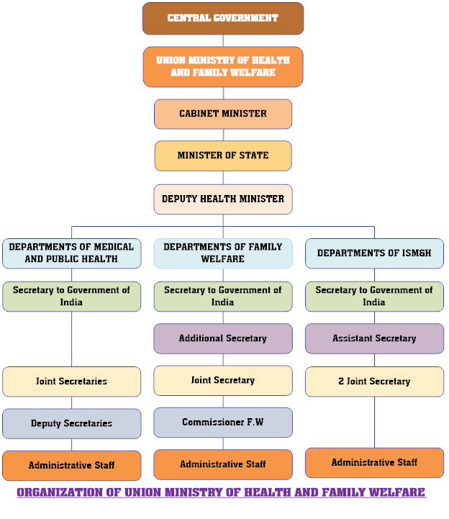With COVID-19 infections crossing the 3.22 Cr mark in India, states have been focusing on the strategy of 'test, track, treat' to contain the spread of the pandemic. Indian Council of Medical Research, ICMR, has continuously been working to ramp up testing across the country. With a growing network of over 1234 ICMR certified COVID-19 testing labs.

1. **Pre-Processing:**

* The pre-processing part done in the form of ETL (Extract, Transform, Load).
* The data extracted from [www.worldometer.com](http://www.worldometer.com)
* The transformation part is done in excel & MSPBI (Microsoft Power BI) Business Intelligence tools. In datasets there are more incomplete & messy data are available such as empty/Null rows & columns, exponent values, spelling mistake, ascending & descending orders mistake in numbers.
* 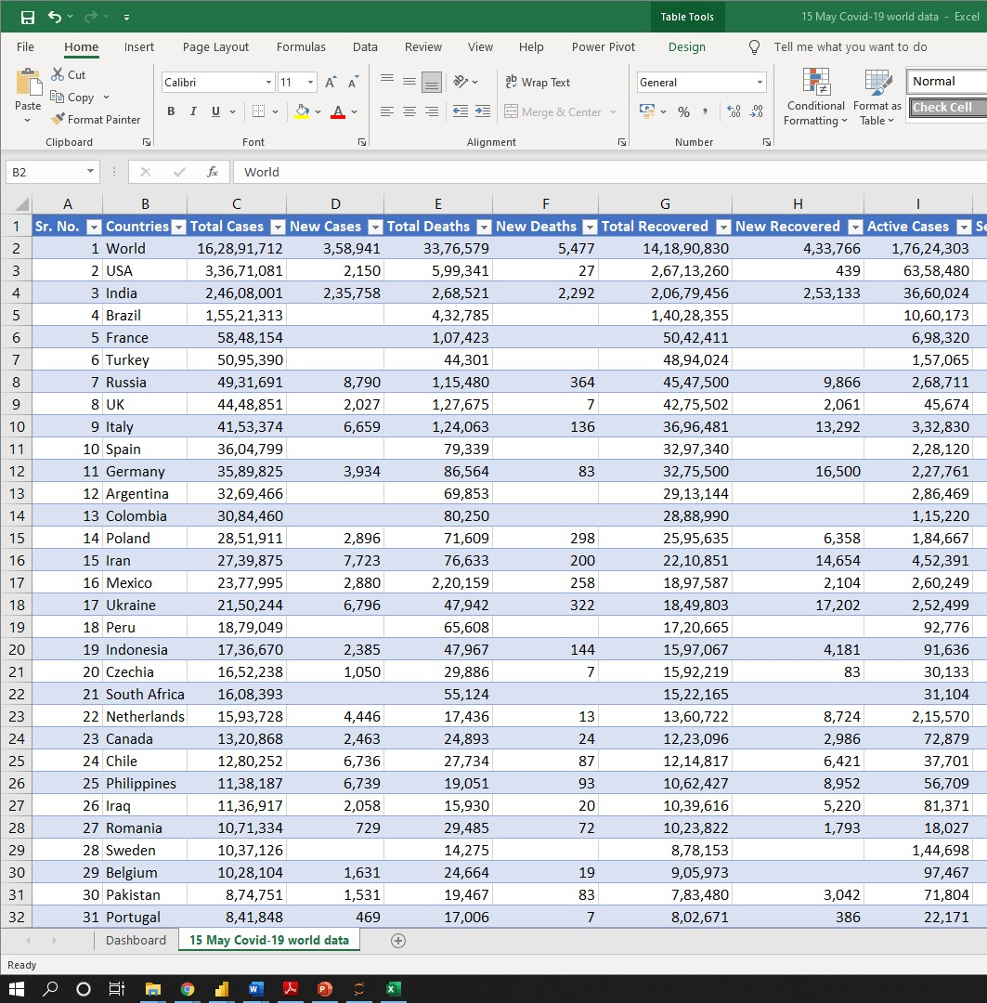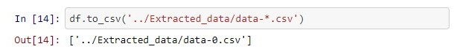The data loading/storing is done in excel through python script:

1. **Data Analysis:**
2. The project of “analysis on world covid-19 data May/June of 2021” data analysis has done with the help of analysis tool MSPBI (Microsoft Power BI) & Excel tools.
3. The data analysis part is done by using interactive visual segments such as donut/pie/sunburst chart, vertical & horizontal bar charts, word cloud, for filtering the data using slicers & cards, bubble & filed maps, scatter plot, ribbon charts, matrix drill down/up tables, line graph & funnel charts.
4. Also, some calculation has done in comparison of two datasets such as creates calculation measures such as DAX (data analysis expression) e.g., using aggregation function like sum, min, max, addition, subtraction, division, average of covid cases, fatality rate, active cases & recovered/cure percentage.
   1. **. Key Performances Indices:**

The KPIs is based on aggregation of six worse affected countries & also collection of two period of time which is May/June of 2021:

* To identifies total number of cases by countries.
* To identifies total new cases by countries & region.
* To knew which country or region has leading in total death/fatality.
* To study on total recovered & new recovered cases by geographical countries & region.
* To identify on one million population, how much critical cases are come.
* Also, the KPIs identifies geographical wise which country has done more tests so far.
* The study to find out the KPIs is what numbers of percentage admitted to hospital in critical condition and how much are cure people coming to the outside.
* In comparison of two datasets the new cases Vs new recoveries in May-2021 India is top most leading country but after 15 days Bolivia took first position in new cases & new recovery rate, also biggest changes identify is after 15 days is India shifted to the 5th position.
  1. **. Dashboard:**

This is a main screen of dashboard, from here there are **7 dashboard** categories in **three parts**:

* In **15 May 2021** Bookmark three dashboards created.
* In **01 June 2021** Bookmark two dashboards created.
* In **comparison** Bookmark two dashboards created.

**Main Screen: -**

In bottom pane by clicking on bookmark right arrow navigate to first dashboard of 15-May-2021 datasets.

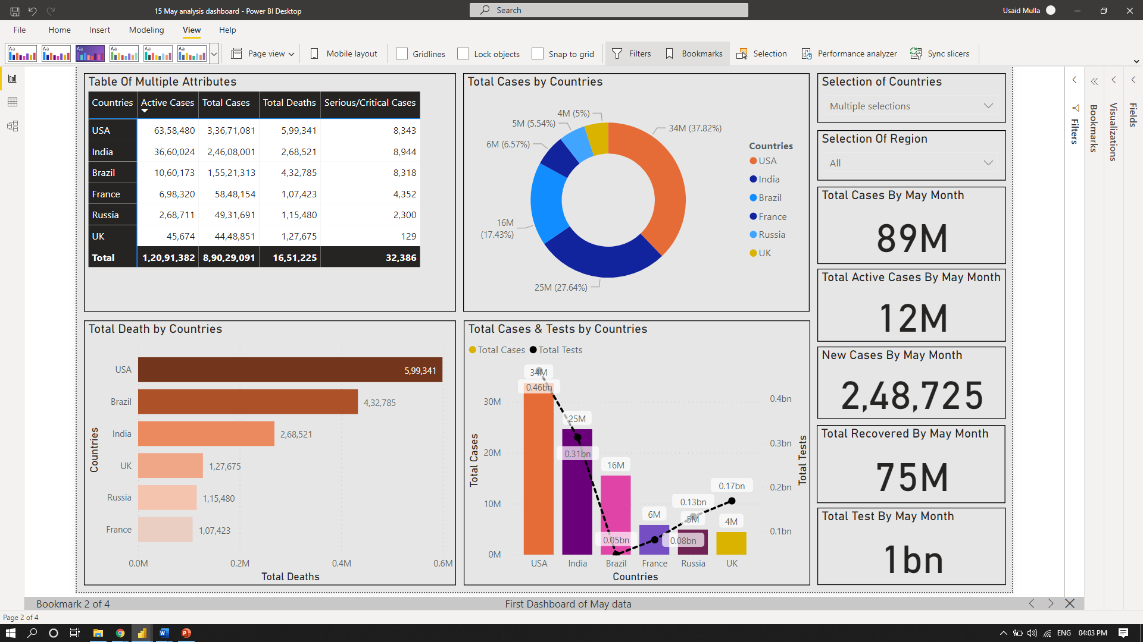

In bottom pane clicking on bookmark 2 forward arrow, it navigates to geographical wise total cases, recovered, & total deaths dashboard.

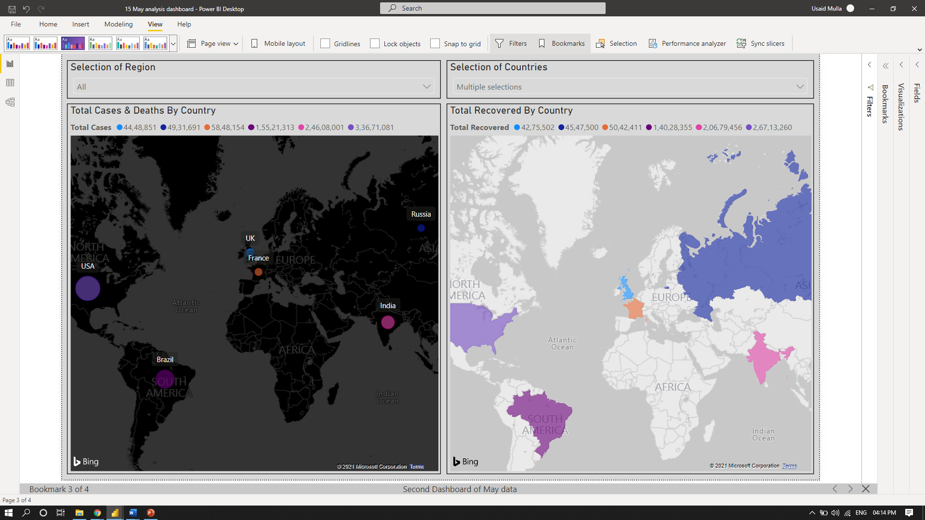

Again, clicking in bottom pane, it navigates to last dashboard of 15-May-2021 dataset, it shows the Total Cases, tests, serious & critical, deaths/mortality cases by region as well as aggregate six major countries.

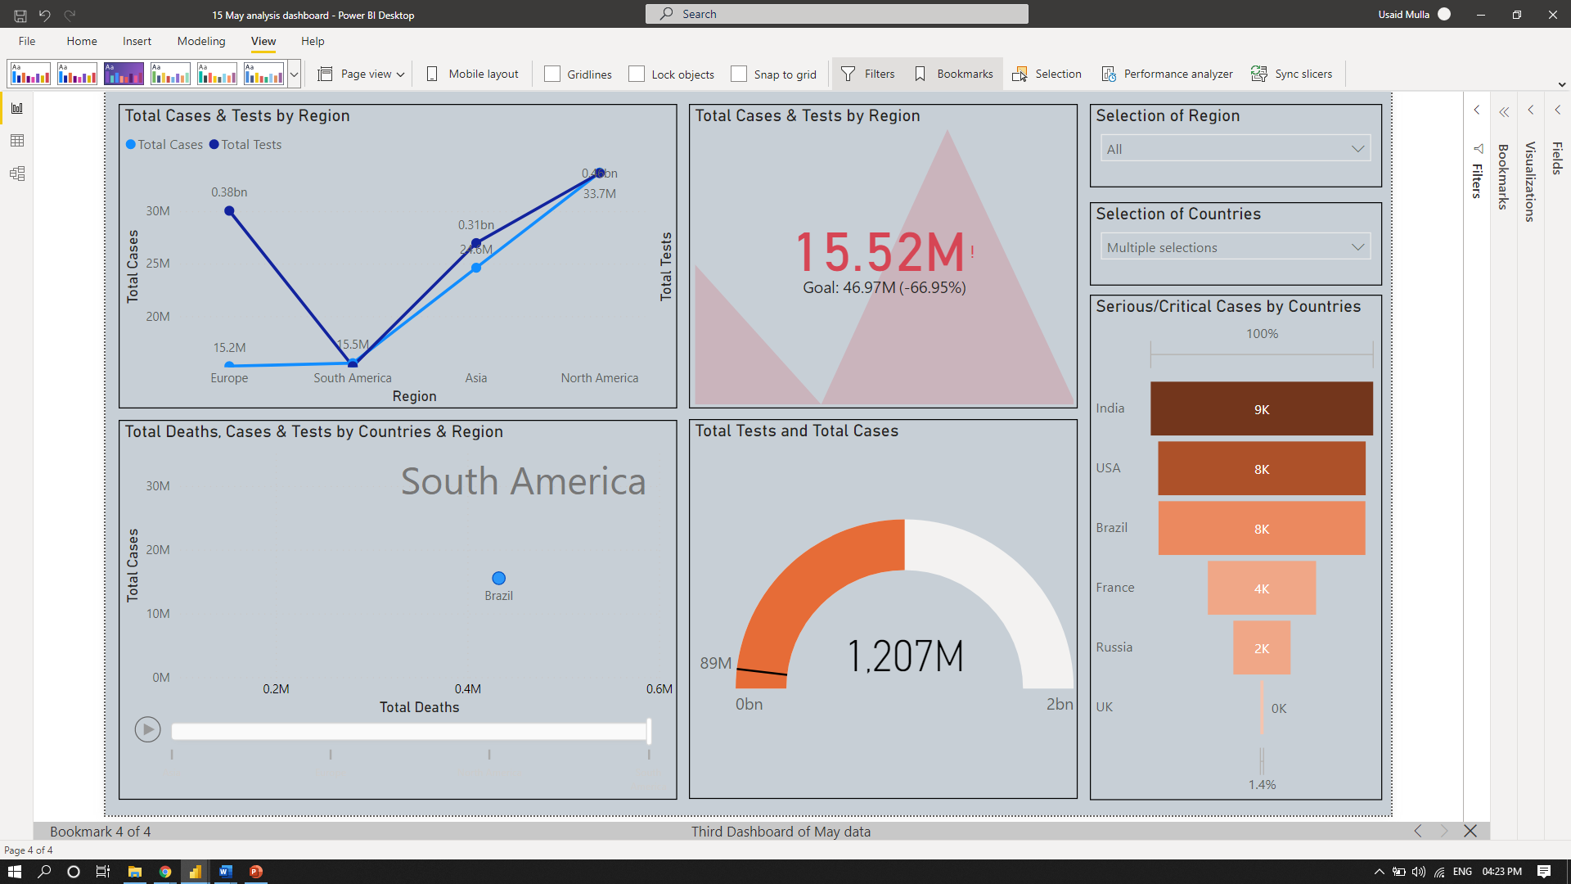

Second category of dashboard is 01-June-2021 bookmark-1 is show the same as the above dashboard.

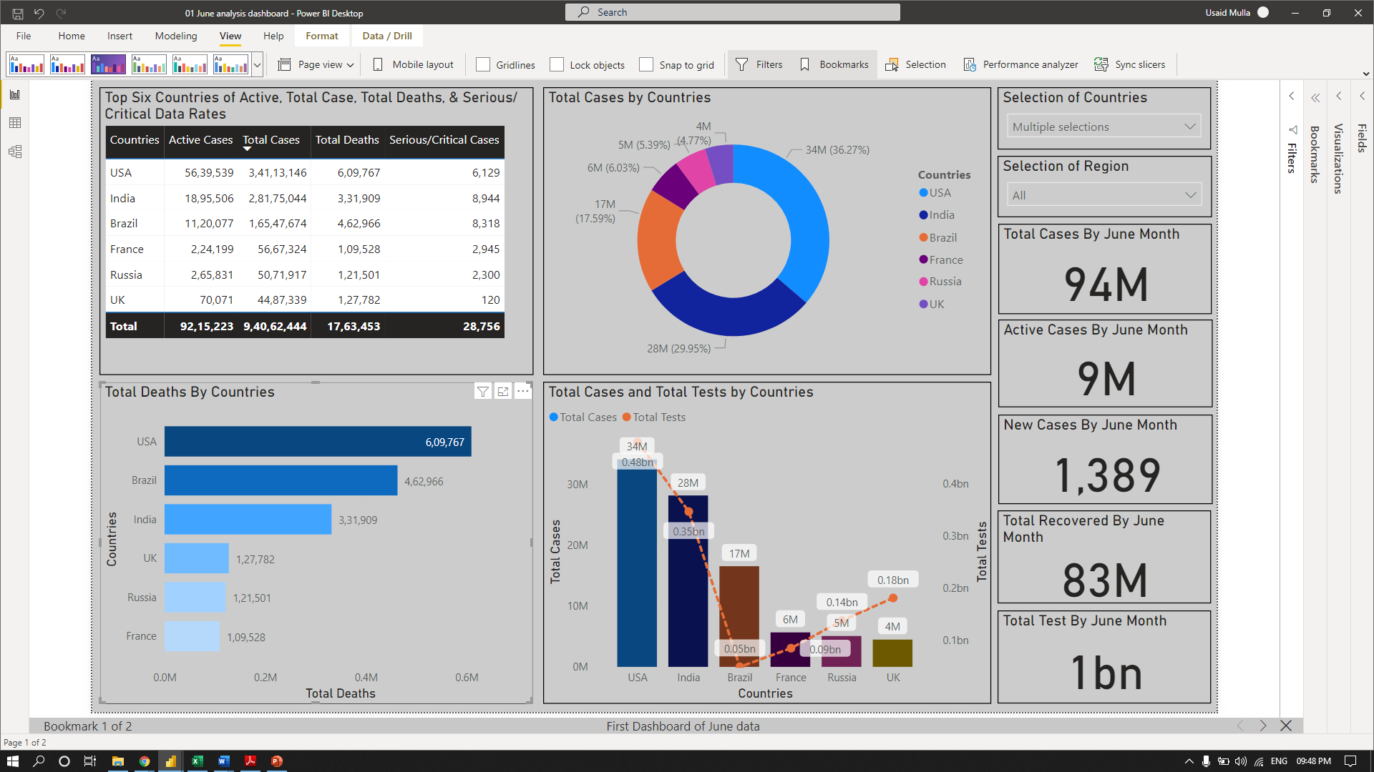

And the last category of dashboard is comparison of two datasets.

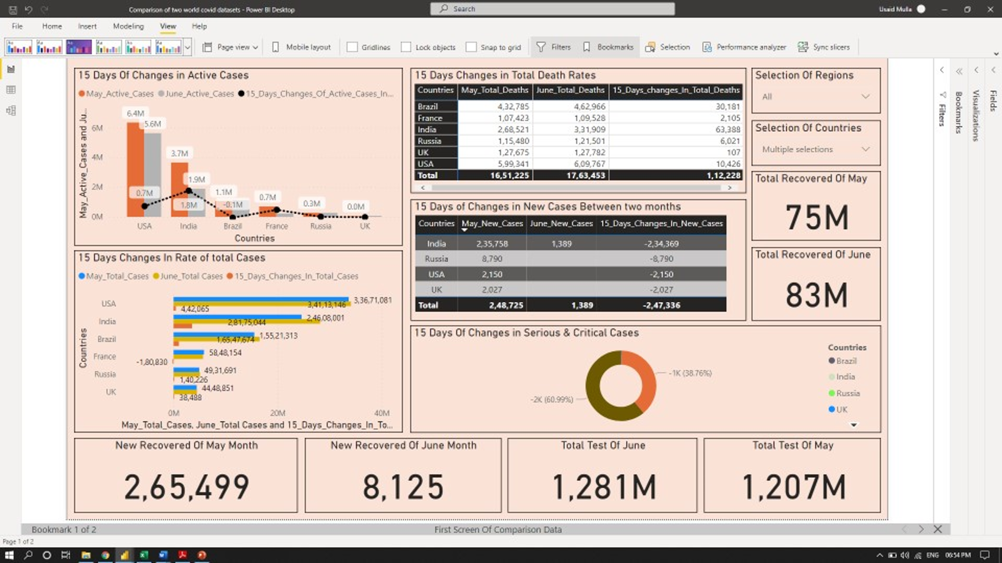

Same as the again go to bottom pane click on forward arrow and it navigate to second dashboard of comparison data.

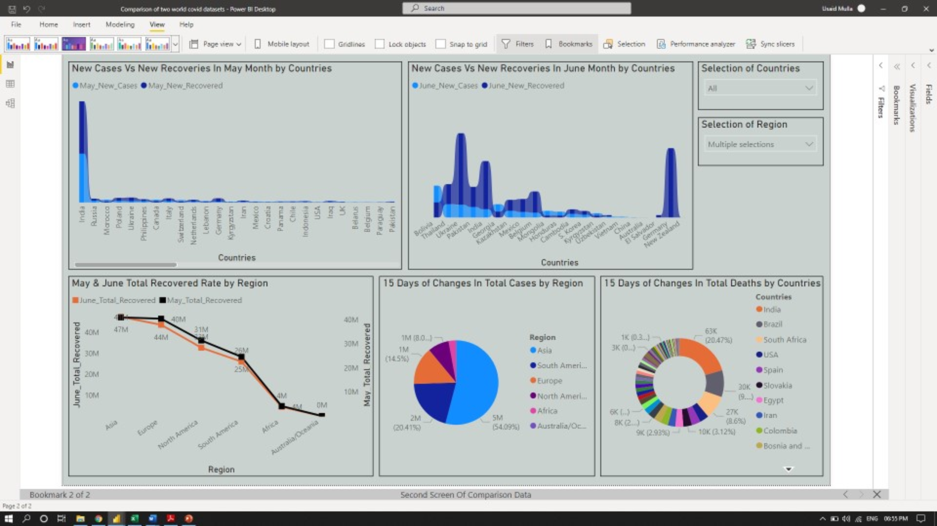

* 1. **. Interactive Reports:**

An **interactive report** is a report that enables users to perform various types of data discovery and analysis (such as drill down drill up, filtering/sorting, using custom visuals to calculate measures) with ease. The purpose of interactive reports is to allow users to independently conduct deeper mining and custom reports on demand, which is common in enterprise-level reports and business intelligence (BI).

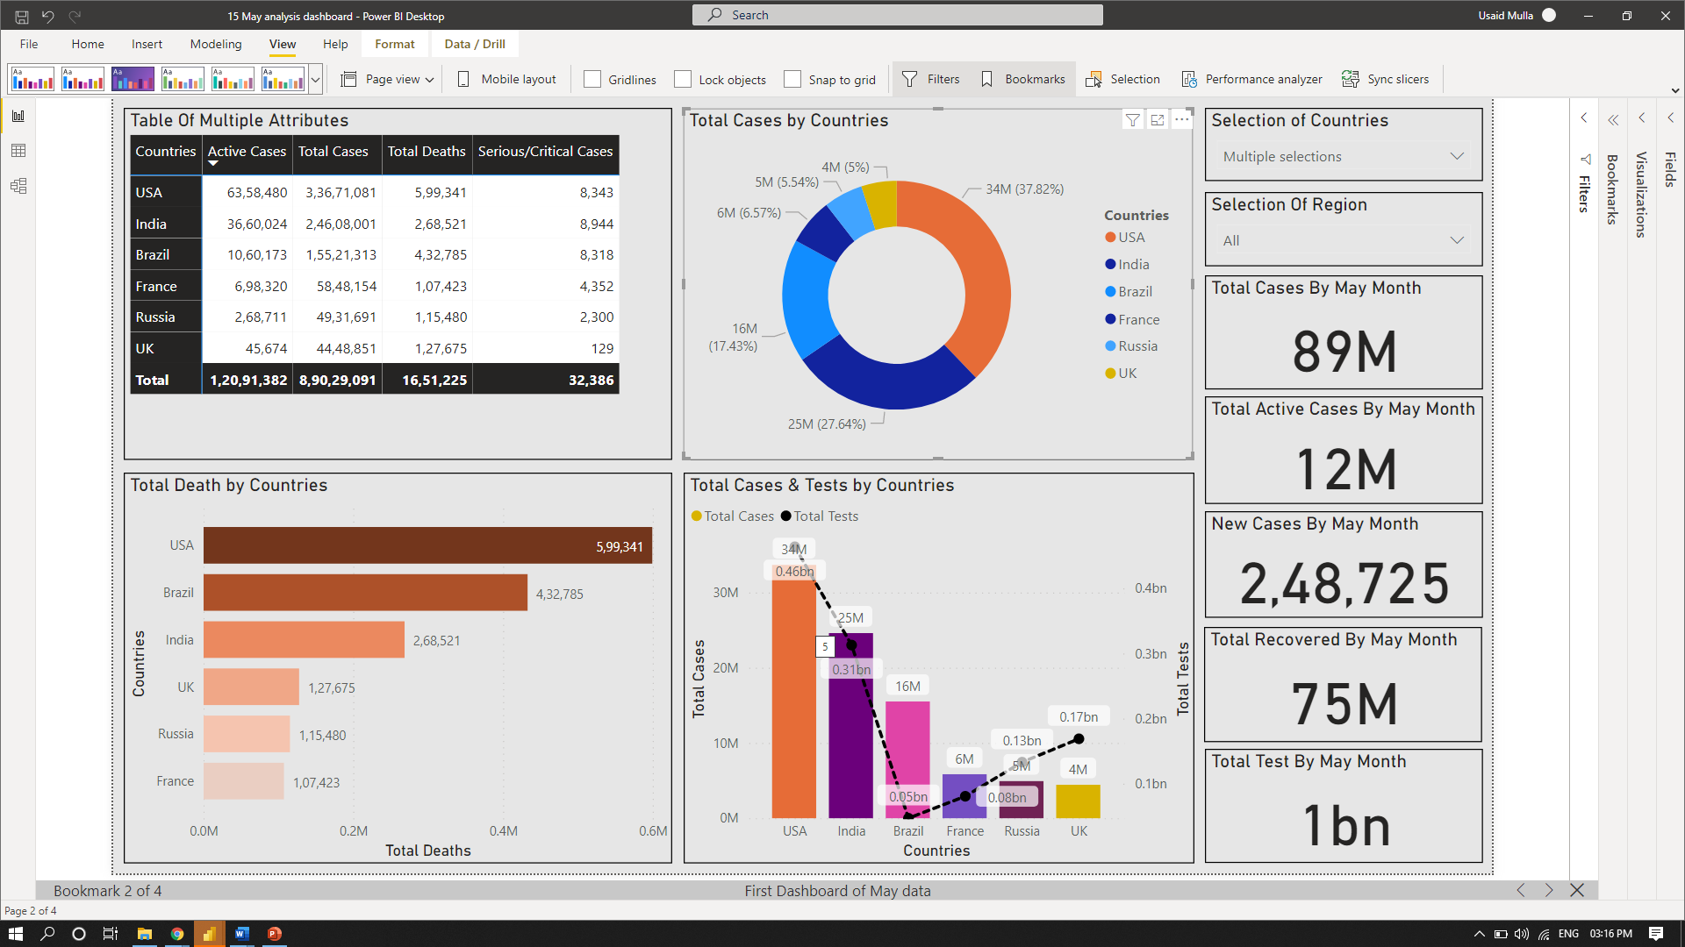

We created some interactive dashboard for changing the visual according to different form where we can easily select any value form the particular visual.

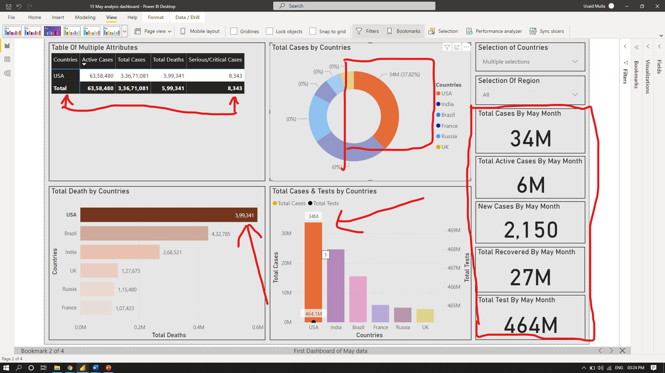

As you can see it when you select the horizontal bar of **USA** country according to the data the whole dashboard changes appeared in visual segments. The selected bar of **USA** country, the bar color got highlighted in dark color, so that the user can understand easily through interactive reports functionality.

1. **Results and discussions:**

As we have shown above 7 dashboards categories in three parts (15-May bookmark-1, 01-June bookmark-2 & comparison bookmark-3), each category has 2/3 dashboard and each dashboard have to many visual segments.

In bookmark-1 first dashboard of May data is: -

* In dashboard first tabular format of matrix is shows the result of six worse affected countries in the world in terms of active cases, total deaths/fatality, serious & total cases. **(Fig: matrix table)**
* Below matrix table the chart is “stacked bar chart’ show the result of total death by countries in aggregate of six country. **(Fig: stacked bar chart)**
* Beside the matrix table the donut charts show the distribution of total cases by countries. **(Fig: donut chart)**
* Below donut visual the “line & clustered column chart” show the result of total cases & test done by countries. **(Fig: line & clustered column chart)**
* In dashboard the top right-hand sides two slicer which are used for “selection of country & region” for drill down/up & filtering, sorting the visual segments. **(Fig: slicers)**
* Below the slicers the five cards are show the numbers of total cases, total active cases, new cases, total recovered, & total tests, all are the aggregation of six countries. **(Fig: cards)**

In bookmark-1 second dashboard of May-data is: -

* Top two slicers show the selection of country & region. **(Fig: slicer)**
* The simple map is showing the result in terms of total cases & death by countries. **(Fig: simple map)**
* Beside simple map the “filled map” is show the result of total recovered in six major countries. **(Fig: filled map)**

In bookmark-1 third dashboard of May-data is: -

* In third dashboard the first visual is line charts show the total cases & test by done in region wise. **(Fig: line chart)**
* Below line chart the scatter plot show the aggregate of six countries in terms of total cases, total deaths, & total tests done by region as well as countries. **(Fig: scatter plot)**
* Below slicers the funnel chart show the serious & critical cases by countries. **(Fig: slicer)**
* The last one is dial gauge is show the how much tests done over the total cases. **(Fig: dial gauge)**

Comparison dashboard of bookmark-1:

* The dashboard of top visual is “line & clustered column chart” is show the result of comparison in active cases of May-June data. **(Fig: line & vertical clustered column chart)**
* Below the vertical column chart, the “horizontal clustered bar chart” show the result of total cases are changes in 15 days. **(Fig: horizontal clustered chart)**
* Also, we used one matrix and table chart for showing the results of May-June total deaths & new cases and after 15 days change value. **(Fig: matrix & table)**
* Below matrix table, the donut chart is present the changes in serious/critical cases or not. **(Fig: donut chart)**
* Below horizontal graph & donut chart, the cards is showing the numbers of new recovered in May-June & total test in both months as well. **(Fig: cards)**

Comparison dashboard of bookmark-2:

* In this dashboard we’re used slicers for all over the world countries covid-19 circumstances. **(Fig: slicer)**
* The first two ribbon charts show the result of May-June of new cases Vs new recovered, and we find out biggest changes in countries position shifting in terms of new cases & new recoveries. **(Fig: ribbon chart)**
* Below ribbon chart the two charts are one is pie & another is donut chart is showing the result of total cases by region & total deaths by countries in 15 days. **(Fig: pie/donut charts)**

1. **Conclusion & future work:**

“Analysis on world covid-19 data” its main purpose is to identify the effects of pandemic to the top most wealth countries in the world. According to this analysis we came to the conclusion that the most affected countries are worse hit by total cases & fatality/mortality rate, serious cases have been identified in USA, India, Brazil, France, UK, Russia. The analysis was done on aggregate of six countries.

The data is extracted in the peak month of May-June of 2021 in these two month we found that in May month the total cases, total recovered cases, total deaths cases, new cases, new recovered, serious & critical cases, active cases, total tests, all this quantifies and are very high by the six major countries in the world, but suddenly after 15 days we also identified that all the given above attributes are being change in 15 days unanimously so somehow the countries are also increasing the tests in age groups, providing government health care facilities, oxygen availability, doctors & front liners workers are working continuously on ground level, also large crowded places are still prohibited & restricted for public safety.

The aim of this analysis of insight is to shows if the countries are increasing the test & vaccination drive in all age groups than we can tackle this pandemic easily, also the covid-19 is still going on and some countries in the world are still in lockdown for example Australia is recently being worse hit and the major cities are facing lockdown till now and some are lifting the restriction of covid-19 virus just like India, USA, etc.

1. **Bibliography**

* Data sets link: -

<https://www.worldometers.info/coronavirus/#countries>

* **About worldometer Wikipedia: -**

https://en.wikipedia.org/wiki/Worldometer

* **Data Analytics in covid-19 By Aboze Brain John Jnr: -**

<https://towardsdatascience.com/scraping-covid19-data-using-python-80120eb5eb66>

* **Related covid-19 article’s: -**

<https://www.spg.pt/wp-content/uploads/2020/04/UpToDate_Coronavirus-disease-2019-COVID-19.pdf>

<https://www.physio-pedia.com/Coronavirus_Disease_(COVID-19)>

* **other supports: -**

<https://www.kapturecrm.com/blog/crm-reporting-and-analytics-how-defining-problems-takes-you-closer-to-solutions/>

<https://economictimes.indiatimes.com/news/politics-and-nation/icmr-increases-testing-as-cases-multiply/states-pitch-in/slideshow/77014421.cms>

https://www.icmr.gov.in/pdf/covid/strategy/Advisory_COVID_Testing_in_Second_Wave_04052021.pdf